

Cuisine 2.0

An AI-powered cuisine for smart consumption with enhanced nutrition



Team: AYB Creations

*Diploma in Information Technology*

*in*

*Big Data Analytics*

**Zeroth Review**

**Feasibility Study**

**Supervisor:** Mr Zoubeir Aungnoo

**AYB Team Members:**

* BABOOLULL Yougesh
* BHAGOOLI Divesh Singh
* SUBRON Jhivesh Kumar

**Date: 07 April 2021**

# Abstract

Food wastage is becoming a real issue worldwide and one of the ways to control it with the help of technology is proper food inventory management and proper grocery shopping. Furthermore, the need to eat a nutritious meal as well as following our diet is a must for good health

The proposed project idea, Cuisine 2.0, doesn’t only limit itself to its objectives but also implements smart features. The cuisine project helped us put into practice our knowledge. This project has also enabled us to enrich our knowledge on advanced topics such as Artificial intelligence and Deep learning.

**Table of Contents**

Abstract 2

Project Proposals 5

Cuisine 2.0 - An AI Powered app on smart consumption for enhanced Nutrition 5

Smart Automated Company Vehicle Management System 5

Industrial Universal Object Defect Detection 5

Project Overview 7

The Cuisine Vision 7

The Cuisine 2.0 App 7

Problems being solved 8

Literature Review 9

Grossing Smart kitchen appliances 9

Evolving Technology 11

Internet of Things 11

Machine Learning 12

Deep Learning 13

Image Processing 13

Artificial Intelligence (AI) 14

Proposed Solution 15

Solution Objectives 16

Project Requirements 18

Cuisine Vision 18

Functional Requirements 18

Non-functional Requirements 18

Cuisine 2.0 App 19

Functional Requirements 19

Non-functional Requirements 19

Project Methodology 21

Project Management 23

Gantt Chart 23

References 24

**Table of figures**

Figure 1: Smart Microwave 9

Figure 2: Revolution's Smart Toaster 10

Figure 3: Samsung's Family Hub 10

Figure 4: YOLO algorithm detecting vehicles 14

Figure 5: Project Gantt Chart 23

# Project Proposals

## Cuisine 2.0 - An AI Powered app on smart consumption for enhanced Nutrition

***[Selected Project]***

**Description:**

A multiform technology to make old boring kitchens smart. It uses an AI engine for object detection in a black box for keeping record of storage of food items in inventory. It also consists of a mobile app which can take out a grocery list whenever required, check inventory, suggest recipe based on available ingredients, list out missing ingredients for a recipe. Suggest healthy food recipes and tips as per the user preferences.

## Smart Automated Company Vehicle Management System

**Description:**

A smart vehicles management system for a company. It consists of vehicle plate number recognition to keep record of vehicles entering and leaving the company. It also consists of reserved parking management which can automatically lower the blockage for the vehicle of the reserved parking user.

There are many commercial versions of the project available.

## Industrial Universal Object Defect Detection

**Description:**

A production system to detect defect of products being produced. Using a trained model, a high-quality camera and a processor, this can be achieved. The system also classifies all products into batches for better identification.

This solution should be able to integrate with the high-quality machines used in factories which can be an issue as not all industrial machines aren’t flexible and the solution must be robust enough to withstand the dire conditions inside the factory which can be costly to implement.

# Project Overview

Good kitchen and food management has been a necessity towards low food wastage and better meal planning. The Cuisine 2.0 project targets old kitchens and upgrade them, by adding smart features. The cuisine project takes into account cost, utility, user interface and flexibility.

The cuisine 2.0 project is multiform technology which has 2 primary parts:

### The Cuisine Vision

This is the IOT part of the project which feature a touchscreen interface. It has wireless connection capabilities to provide a number of additional features. The main feature of Cuisine Vision will use camera and AI for real-time food detection, which will then be pushed directly to the inventory database. This system will be wrapped up in a Blackbox which can be equipped on the refrigerator door. Moreover, the AI powered Blackbox is also practical for people who are changing their refrigerator or shifting houses, because it can be attached to and detached from any fridge with ease.

### The Cuisine 2.0 App

It is a cross platform app which is available on Android and IOS platform. It includes kitchen and food management functionalities. It has various features that makes kitchen management, grocery planning and cooking easier for its users. It offers the ability for you to interact with its features using your smartphone or tablet when away from home.

# Problems being solved

“Throwing away food is like stealing, from the table of those who are poor and hungry”, quoted by Pope Francis. Around 1.3 billion metric tons (1.43 billion tons) of food, or one third of what is produced for human consumption, gets lost or wasted every year, according to the United Nations’ food agency.

There are many issues with kitchen and food management while the greatest of all is Food Wastage. There are many more problems related to kitchen management in general such as **Improper inventory management**, **Imprecise grocery lists, Overbuying and Underbuying.**

The Cuisine 2.0 project targets the below listed issues:

* Food is spoilt at home due to improper storage management as sometimes it may not be visible to the user to consume or he might have forgotten about it. This may result in the food getting expired as people usually don’t remember the expiry dates of all food items.
* Preparing a grocery list may be sometimes challenging. The first issue with grocery list planning is inability to explore the whole inventory to get an accurate grocery list. This may cause an issue for busy workers as they don’t have time to evaluate their inventory. This may result in overbuying and underbuying of food items. Overbuying of food items may result in stale food if the food needs to be consumed within a short period but is present in large quantity. Underbuying may result in lack of food items for consumption.
* With a busy life and busy schedule, food becomes a low priority. Lack of time to reflect on a healthy meal preparation in a short period of time become a major problem. They may find it hard to plan and maintain a nutritious diet.
* Some people find it really hard to decide on their meals. Although they have all the ingredients present, they find it difficult to choose what to cook today.

# Literature Review

“100 million people are starving. 1.3 billion tons of food is wasted every year. We do not need to produce more. Instead, we need to act different.” - **Chef Massimo Bottura** (famous Italian restaurateur).

A few years back, voice assistants like Amazon Alexa and Google Assistant were not as common as nowadays. Technology has advanced to such extent that you can even talk to your microwave or your refrigerator. A lot of smart kitchen appliances have entered the market recently which include the same technologies as google assistant and smart phone features.

## Grossing Smart kitchen appliances

Smart kitchen appliances are all over the market. This is a small list of interesting smart kitchen appliances that are worth knowing about:

1. **Smart microwaves or ovens**

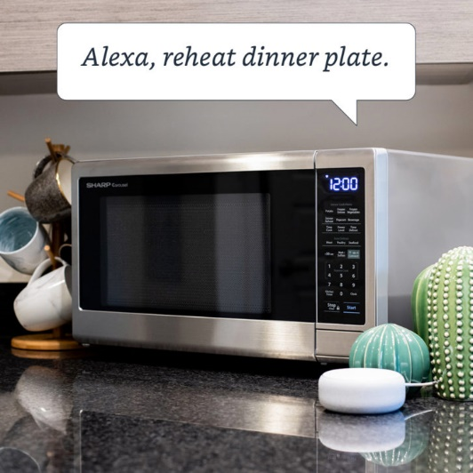

Figure : Smart Microwave

Smart microwaves simply have in-built Google assistant and Amazon Alexa or WIFI-enabled which allow you to connect your assistant devices. This allows the user to talk to the oven to do basic things instead of doing it manually. For example: if you have your food in the oven and want to heat it again. You can just say: “Alexa, heat the dinner one more time”; and the oven will be on for you.

1. **Revolution Cooking Smart Toaster**

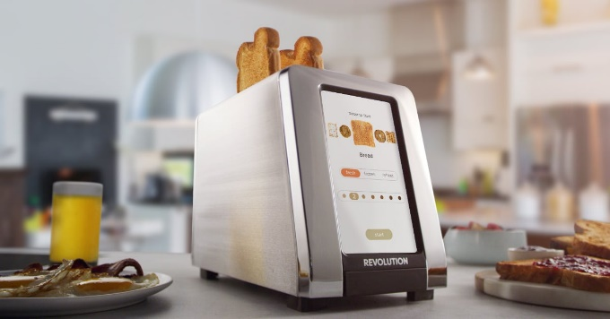

Figure : Revolution's Smart Toaster

Revolution Smart toasters is a toaster that helps you cook your toast properly, ideal for people who care about having perfect toasts for their breakfast. This toaster allows the user to input the type, state of the toast and also how brown he wants it to be. The toaster cooks the toast as per the information input and the user gets a perfect toast.

1. **Smart Refrigerators**

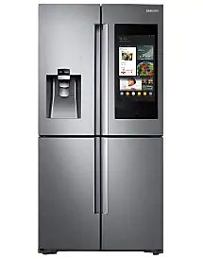

Figure : Samsung's Family Hub

Smart Refrigerators are the top grossing appliance when it comes to smart kitchens. The top brands in smart refrigerators are Samsung, LG and Bosch. Samsung’s Family Hub Refrigerator has been the in the front line for a while because of the abundance of smart features for a busy family. A few of these refrigerators also take into account proper food management, which is one of the main objectives of the Cuisine 2.0 project.

## Evolving Technology

Digitization is really on the edge of taking over the whole world. Years ago, we could only wash our clothes in the washing machine, nowadays, we have voice assistant in built, allowing us to talk to our washing machines.

These evolutions have been possible with continuous development and progress being made on Internet of Things (IOT), Machine Learning, Deep Learning and Artificial Intelligence (AI) Technologies.

### Internet of Things

The **Internet of things** (**IoT**) describes the network of physical objects— “things” or objects—that are embedded with sensors, software, and other technologies for the purpose of connecting and exchanging data with other devices and systems over the Internet. –Wikipedia.

In simple terms, IOT allows different devices to communicate to each other, to exchange information such as sensor data and signal data, thus forming a network. IOT has allowed technology to advance a step further towards making any physical device smart.

The concept of IOT has existed since a long time ago, but the recent technological progress has made it practical:

1. **Availability of low cost and low power chips**

This allowed more manufacturers to work on IOT technologies with affordable and reliable sensors.

1. **Easy access to wireless connectivity**

The increased access to broadband internet and cellular network has been an important step towards the development of IOT. Additionally, with the support of IPv6, more devices can now be provided an IP address allowing more connections. There are a number of IOT connectivity solutions, such as, Bluetooth, Radio Frequency Identification (RFID), WIFI, Lora WAN and Sigfox.

1. **Availability of Cloud platforms**

This has enabled IOT to gain a platform where its data collection and device management capabilities are put into practice by making analysis and providing better understanding of the data collected.

1. **Integration of Artificial Intelligence to IOT devices**

Adding intelligence to IOT devices has made it more attractive and feasible for home use, that is, to integrate into the life of people.

### Machine Learning

Machine learning focuses on applications that learn from experience and improve their decision-making or predictive accuracy over time. – IBM.

Basically, Machine learning takes data, trains the dataset, runs an algorithm on that dataset to create a model and uses that model for automatic prediction and data analytics with minimum human. Machine learning is the ability of machines to learn without being programmed explicitly.

There are 3 main learning methods:

1. **Supervised Learning**

In supervised learning, labelled datasets are used to train the models to classify or predict outcomes accurately.

1. **Unsupervised Learning**

It makes use of unlabelled data, where the model tries to extract patterns and features from the data on its own.

1. **Reinforcement Learning**

In this type of learning, the algorithm learns through trial and error. It has 3 components: agent, environment and actions. The agent is the decision maker which decides which actions to take after interacting with the environment.

### Deep Learning

Deep learning, also known as deep neural networks or neural learning, is a form of artificial intelligence (AI) that seeks to replicate the workings of a human brain. It is a form of machine learning, with functions that operate in a nonlinear decision-making process. Deep learning occurs when decisions are made on unstructured data without supervision. Object recognition, speech recognition, and language translation are some of the tasks performed through deep learning. – Investopedia.

Deep learning works with artificial neural networks which are basically layers of nodes, pretty similar to a human brain. Deep learning has grown alongside the digital era which has caused an enormous unstructured amount of data called Big Data to be collected.

### Image Processing

It deals with the manipulation of images to extract useful information from them or get a better version of them. Machine learning and deep learning has made image processing more accurate and better than the traditional image processing. Through image processing, we can perform tasks such as classification, feature extraction, pattern recognition, removing noise from image, image editing and much more.

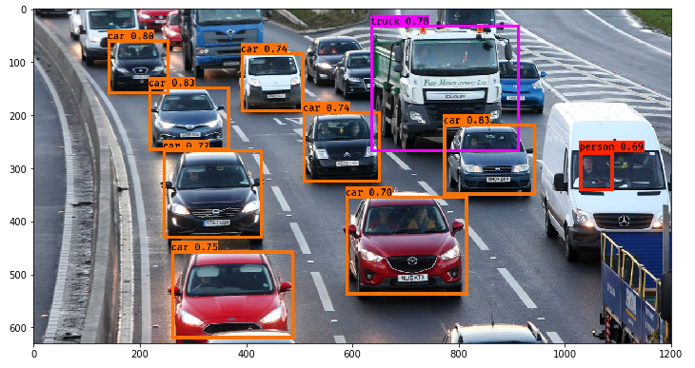For object detection in images, a pre-processing is done to clean the image data for the model. A technique called bounding box is added to the image to bound the object being detected. The algorithm compares its predicted bounding box and the ground-truth label box (labelled images). Image classification use machine learning algorithms such as K-nearest neighbour and Support vector machines (SVM). Deep learning algorithms include Convolutional Neural Networks (CNN).

Figure : YOLO algorithm detecting vehicles

### Artificial Intelligence (AI)

Artificial intelligence is the ability of machine to mimic the human brain. It is the use of machine learning and deep learning techniques to solve actual problems “smartly”. It classifies, analyses or draw predictions from data. It keeps on learning from the new data and improves over time. A good AI tries to figure out what it should do when it comes across any unfamiliar situation. It trains a specific program for a specific task and allows it to explore and improve on its own. AI requires a huge amount of historical data to identify patterns from. The larger the dataset, the better the AI gets through pattern recognition. This allows the AI to make predictions or take actions faster and better.

We interact with AI technologies almost every day, such as:

1. Email filtering

Spam or category filtering of emails.

1. Smart replies in messaging or in email services

Suggested replies for received message.

1. Chatbots

They recognise patterns of the words send and delivers useful content.

1. Predictive searches

Predicting your search based on data collected about you

1. Recommender System

Recommendation systems are available almost everywhere to suggest you based on data collected about you. For example: music suggestions, product recommendations

1. Maps and Directions

They provide the most optimised way of reaching a destination based on traffic, road closure and many more factors. Google maps is one of the best smart maps available.

# Proposed Solution

Cuisine 2.0 is a multiform technology project that has a primary target which is reduce to food waste trough proper food management and buying. The solution has object detection capabilities in the cuisine vision which can detect food items to record in the virtual inventory. We also have a mobile application that can synchronise the to the user’s virtual inventory providing him access to his inventory every time. The app also generates the grocery list for the user.

# Solution Objectives

The Cuisine 2.0 project targets old and boring kitchens and improve the way it functions. It focuses on smart consumption of food and eases life of busy people.

1. **Help reduce food wastage**

Smart Cuisine 2.0 aims at reducing food wastage through better inventory management and acts as a virtual assistant to the user. The Smart Cuisine App will notify the user about any food which is going to expire or any food that is going to become stale.

1. **Making grocery runs easier**

Preparing the grocery list before going on a supermarket run is really time consuming and hectic specially for toilers. Cuisine 2.0 has made it simple for them. On a click of a button, the app gets the pre-configured list, queries the inventory of the user and prepares the grocery list with items that need to be bought. This also solves the issue of overbuying and underbuying. If the user wants to cook a meal but has inadequate ingredients, the app can automatically make a list for the items he wishes to buy.

1. **Recipe Suggestions**

Often people are confused at what they should cook with the available ingredients. The Recipe Suggestion feature allows the user to view the meals he can cook with the available ingredients and facilitates his choice.

1. **Integrating into the life of busy workers**

One of the app features is Meal planning which allows the user to follow his diet and eat healthily based on his health. The app reminds the person to follow his healthy diet.

1. **Upgrade through Addons**

This project is an addon to existing kitchens, improving the way it functions. That is, the user doesn’t have to buy new appliances to get the smart features. They can just stick the cuisine vision device in their kitchen and use the cuisine App from their smartphone.

1. **Cost-effective**

The cuisine 2.0 is a low-cost device and will be affordable to an average person.

# Project Requirements

## Cuisine Vision

The Cuisine Vision is a tablet-like touchscreen integrated with a camera. The user will first power on the device using a button. Upon powering on, a login page will be displayed in the screen that will ask the user to authenticate himself by entering his username and password in order to gain access to the features of Cuisine Vision.

### Functional Requirements

1. Registration, Login, reset password options
   * If authentication is successful, the user is directed to the application page.
   * In case authentication fails, the screen shows an error message about the failure.
   * In case a user has forgotten his username and/or password, on a click of a button the user can reset his password via email.
2. Food item detection to update inventory
3. Device automatically goes into sleep mode in case of inactivity to reduce power consumption.
4. A session is locked due to inactivity.
5. Informative prompt messages and notification sounds.

### Non-functional Requirements

1. Cuisine Vision is a user-friendly interface accompanied by large touchscreen buttons. The user can interact with the interface by simply the use of his fingertips.
2. Cuisine Vision is a safe and secure environment which is integrated with secured and encrypted (SHA-256) connections to protect the user’s data from potential hackers.
3. The user’s data is protected since a login page is prompted before accessing the features of Cuisine Vision.
4. Cuisine Vision is designed with vibrant themes which are eye-catching and hence, keeps it entertaining to navigate through the features. (Increase readability.

## Cuisine 2.0 App

Cuisine 2.0 is a cross platform mobile application which supports both Android and IOS. It has smart features that synchronises to an online database for grocery list generation as well as inventory viewing.

### Functional Requirements

1. A registration page for the user to register to Cuisine 2.0.
2. A login page is prompted to the user before accessing the dashboard and its various features.
3. If the user successfully login to his account, he will have a clear view of the dashboard in which quick links to various features will be available to access.
4. In case the user fails to login, the screen shows an error message about the failure.
5. In case a user has forgotten his username and/or password, on a click of a button the user can reset his password via email.
6. Member profiles.

### Non-functional Requirements

1. Easy access menu of Cuisine 2.0 features.
2. Notifications/reminders system.
3. Tip of the day feature that looks for the most appropriate food item while considering the conditions that it will not suggest repeated food item every day and also takes into account food that are going to expire.
4. The user should set how long the food item will last. Some food items already have a predefined lasting period which are still to be confirmed on adding to the inventory.

# Project Methodology

My team have decided to adopt the **Evolutionary** **Prototyping project methodology.** A prototyping model is a system development model whereby a prototype is developed, tested and reworked until the desired end result is reached. In Evolutionary prototyping methodology, a prototype is built with well understood specifications and then the initial prototype is refined to develop the final system unlike the throwaway method where once the requirements are clear these prototypes are thrown away and the final system is developed using other process models.

Basically, we have presented and explained the idea of our project to our supervisor. Our supervisor will be giving us feedbacks on the prototypes we build, so that it can be improved to get the final system. The prototyping method is broken down into 5 phases:

1. **Communication**

In this phase, developers are required to gather information about requirements of the project. To gather the required information, we will be conducting surveys, questioning different people and observe kitchen management through internet research.

1. **Construct prototype**

Based on the clear requirements, a prototype will be made. During the construction of the prototype, objectives of the project will change based on the features from the initial planning. It is a low cost but fast development of the prototype.

1. **Evaluation**

Once a prototype has been developed for the project, it is checked against the requirements gathered in the communications phase. If it meets the requirements and the customers are satisfied, we move to the deployment phase, otherwise the modifications are suggested.

1. **Prototype Iteration**

Based on the modifications suggested, developers will modify the prototype and will be resent for evaluation. This loop will continue until a prototype that satisfy the requirements is met.

1. **Deployment**

After having iterated through the modifications and the prototype that satisfy the requirements has been found, developers will start developing the final version of the project.

# Project Management

## Gantt Chart

The Gant chart in the following pages describes the main tasks in our project, following the evolutionary prototyping methodology.

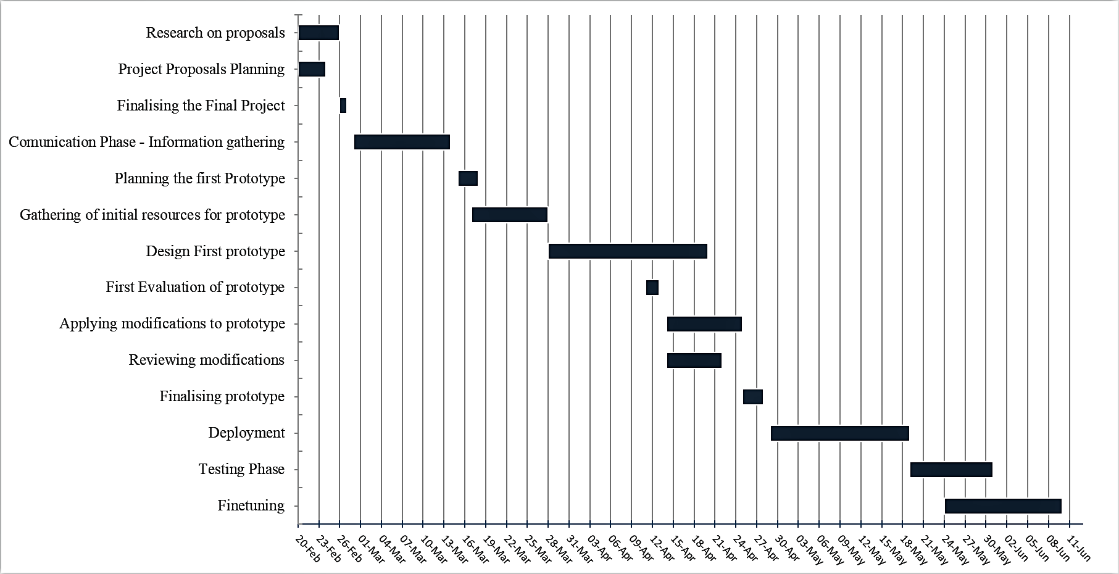

Figure : Project Gantt Chart

# References

Avsystem.com. 2021. *What technologies are used in IoT – technology behind Internet of Things*. [online] Available at: <https://www.avsystem.com/blog/iot-technology/>.

Johnson, J., 2019. *16 ways to reduce food waste at home, school, and more*. [online] Medicalnewstoday.com. Available at: <https://www.medicalnewstoday.com/articles/327325>.

Oracle.com. 2021. *What is the Internet of Things (IoT)?*. [online] Available at: <https://www.oracle.com/internet-of-things/what-is-iot/>

Ranger, S., 2021. *What is the IoT? Everything you need to know about the Internet of Things right now | ZDNet*. [online] ZDNet. Available at: <https://www.zdnet.com/article/what-is-the-internet-of-things-everything-you-need-to-know-about-the-iot-right-now/>.

Sas.com. 2021. *Machine Learning: What it is and why it matters*. [online] Available at: <https://www.sas.com/en_us/insights/analytics/machine-learning.html#:~:text=Machine%20learning%20is%20a%20method,decisions%20with%20minimal%20human%20intervention.>.